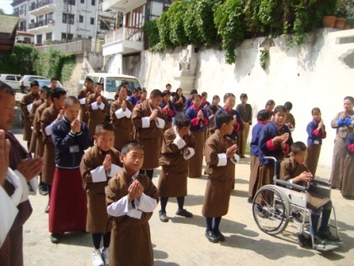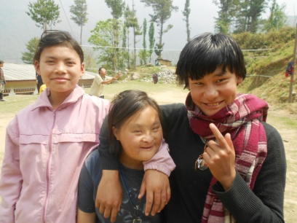 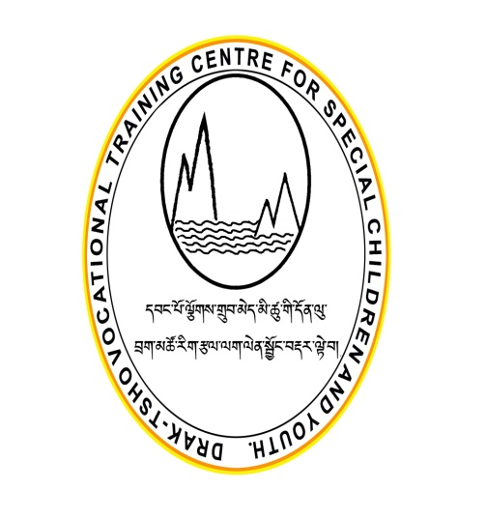 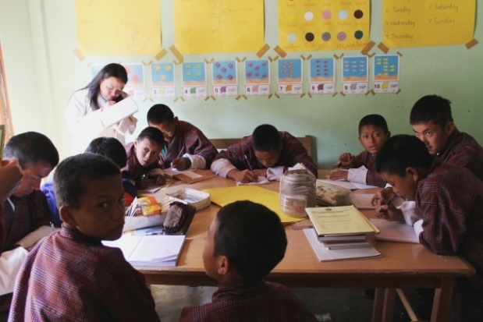 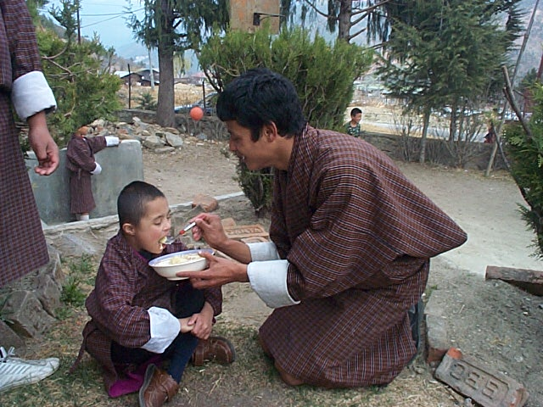

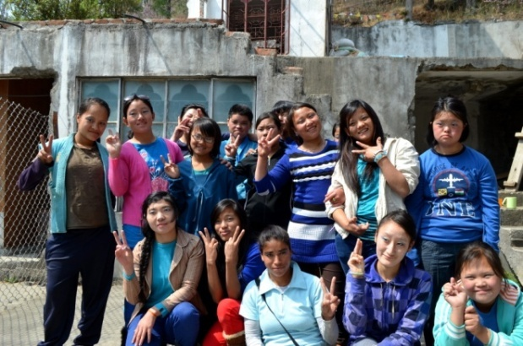 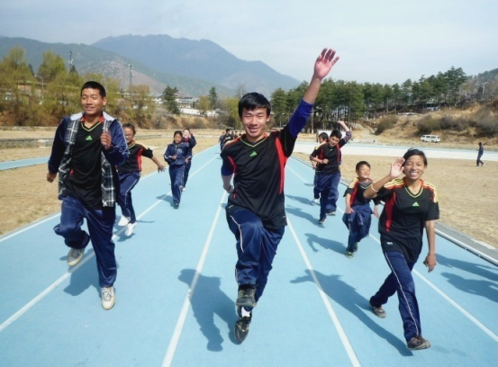

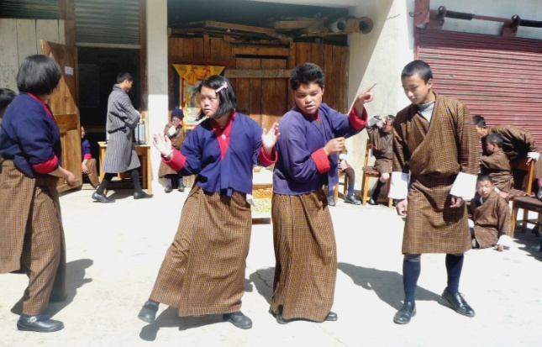 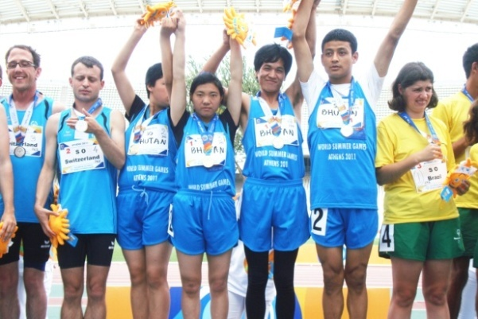

**ANNUAL REPORT 2014**

Table of Contents

**Going Foreword** 3

**Participation during recitation of Bazaguru Dungdrup at Trashi Yangtse District** 4

**Khuru competition** 4

**The students also helped the community at the cleaning campaign** 5

**World Autism Day Celebration** 6

**Teachers Day Celebration** 7

**Fashion Show** 8

**Awareness Programme** 9

**National Sports Competition** 10

**Cultural programs performed by persons with disabilities** 10

**Guest participating in the blindfold race** 11

**Hon’ble Minister Mingbu Dukpa awarding the prizes** 11

**Disability Registration Program** 12

**Athlete Leadership Program** 13

**Leadership Academy Training** 14

**Needs Assessment of Draktsho** 15

**Celebration of International Day of Persons with Disabilities** 18

# **Going Foreword**

I would like to take this opportunity with immense joy and satisfaction to share Draktsho’s annual report for the year 2014. After 14 years of successful operation Draktsho has expanded over coming all types of challenges fulfilling its goal taking a step forward with every year passing by.

Over the years, Drakthso has many changes, growing its scope of programmes and activities. We now have a wide range of platforms –including volunteerism, internship opportunities, and cultural showcase, student exchange programmes and collaboration with international NGOs. This expansion and partnership have not only raised awareness about our activities but also strengthened our bonding with the society at large.

Draktsho faces a future filled with new challenges and opportunities. We are a growing organization aiming to fulfill the needs of our children and youth with disabilities in Bhutan, to share knowledge, reach out to the communities, experience joy and happiness in pursuit of Gross National Happiness.

To all our staffs, families, partners, sponsors, friends, society at large and our special people I say “thank you for all your support, cooperation and well done”. Let us not just be content with keeping up what we do, but also reflect on how we can create an even greater impact, at home, at schools and on every national and international stage.

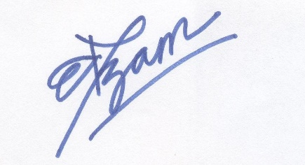

Deki Zam,

Deputy Director,

Draktsho

# **Participation during recitation of Bazaguru Dungdrup at Trashi Yangtse District**

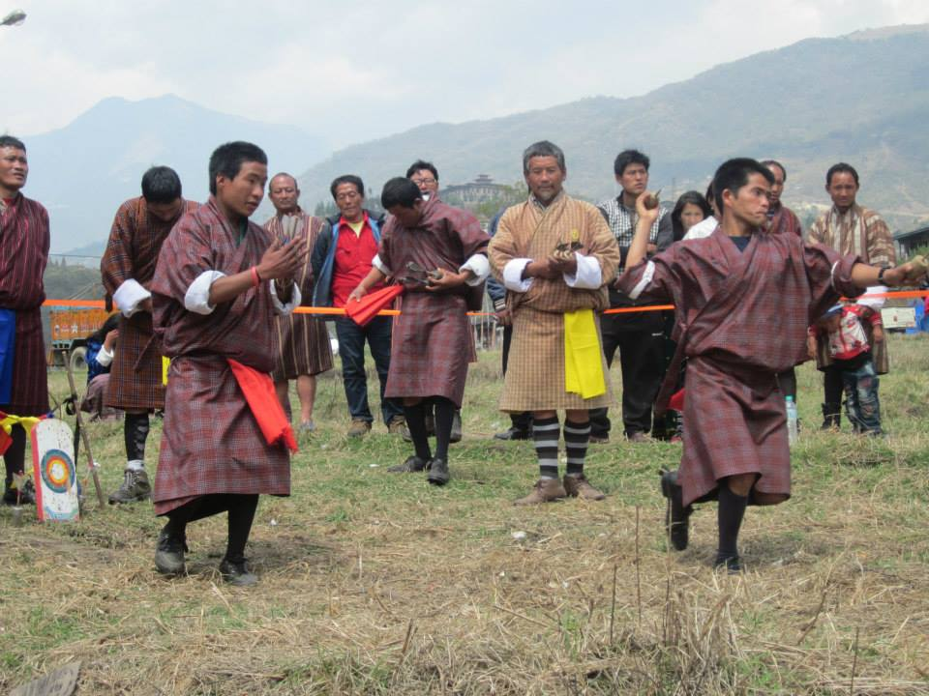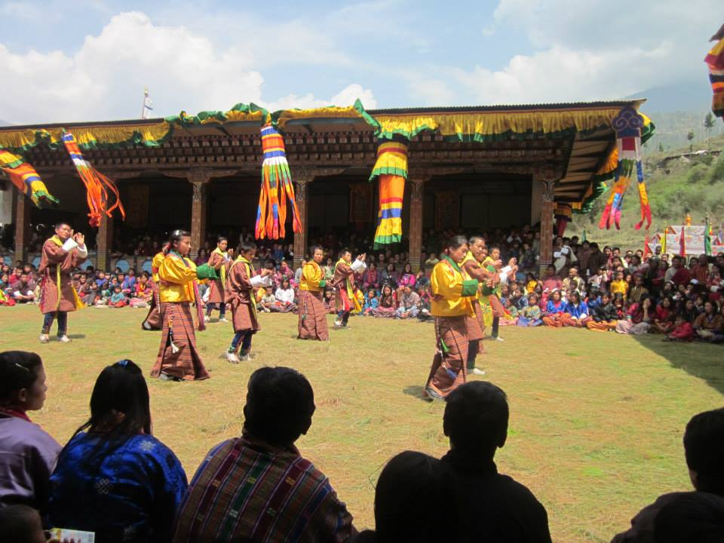

## **Khuru competition**

Bazaguru Dungdrup recitation programme was initiated by people of Trashi Yangste Dzongkhag for the well-being of all sentient being. Every year, corresponding to the 1st month of Bhutanese calendar, a ceremony is conducted by a renowned lama for duration of 15 days. This year, Draktsho east also got invitation from the Bazaguru Dungdrup Association where the students and teachers participated at the event for three days. His Holiness Khamtrul Rinpoche inaugurated Draktsho’s membership form by donation Nu: 50,000/. The students showcased their talent through dance and sport competition like khuru with the people of Trashi Yangtse. Draktsho student’s team won the first prize amongst 15 other local teams. This event not only gave equal opportunity to students with disabilities to participate with the local community people but also helped raise awareness about disability.

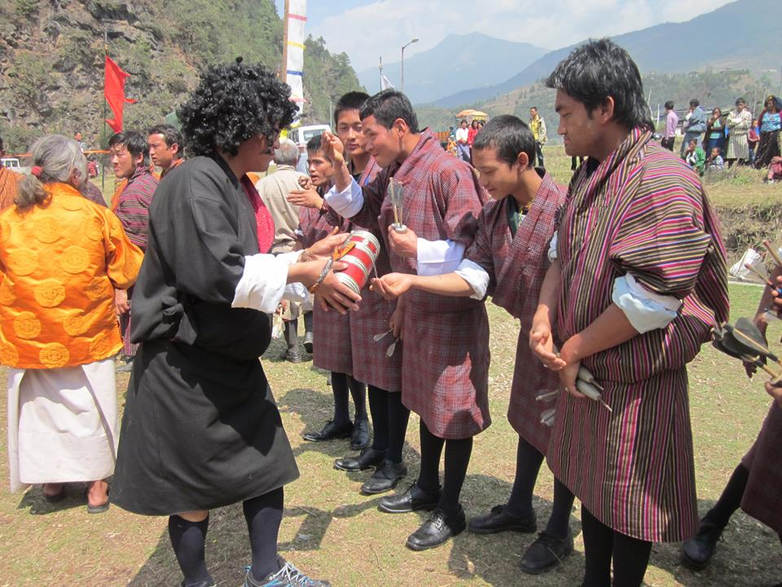 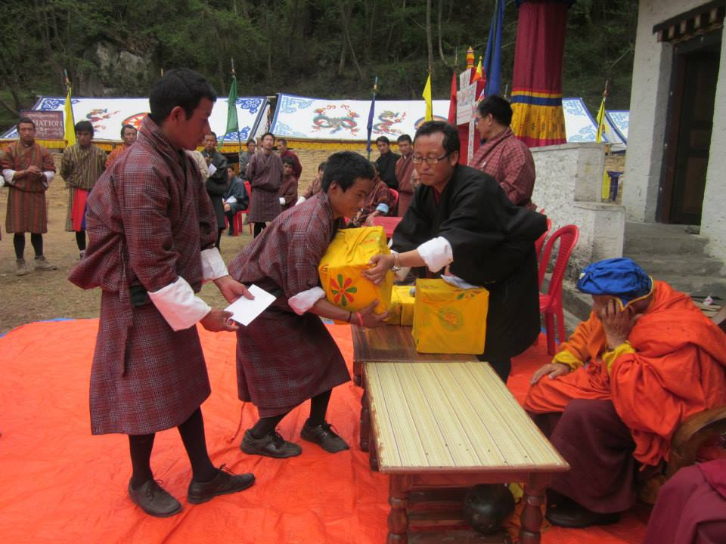

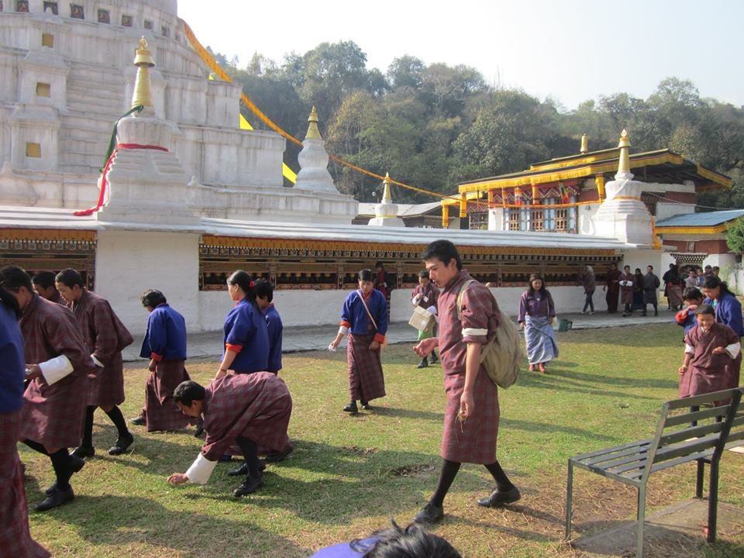 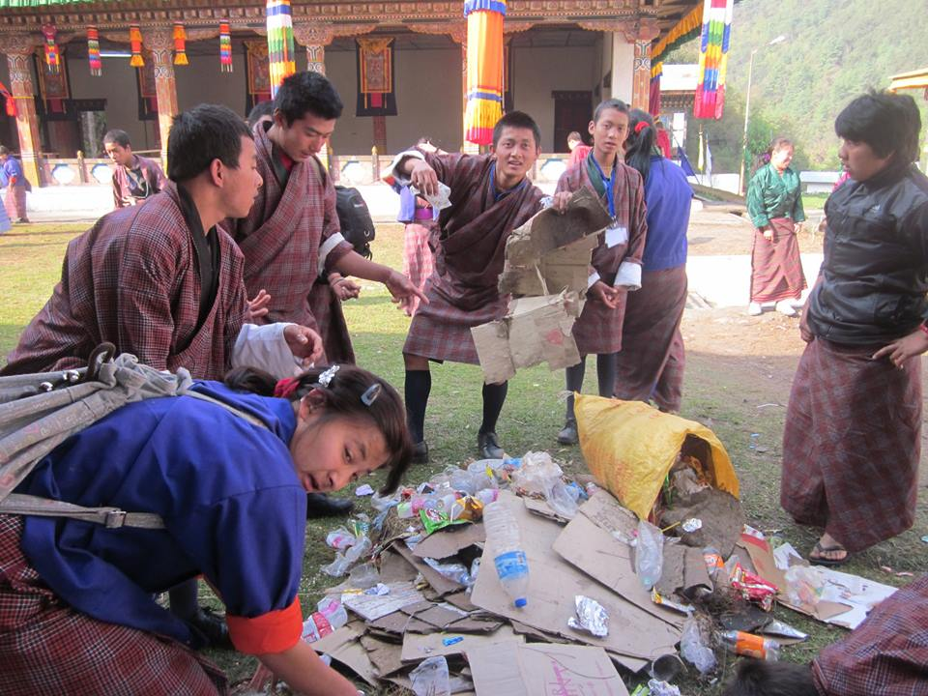

### **The students also helped the community at the cleaning campaign**

# **World Autism Day Celebration**

On 2nd April, 2014 the World Autism Day was celebrated at Draktsho Thimphu centre by lighting it up all blue. All students and teachers drove by town to raise awareness which was followed up by a 1 ½ hour trip to Paro Deaf Education Unit. The Deaf Education Unit at Paro Drugyel Higher Secondary School is an integrated school which caters educational services to children and youth with hearing and speech impairment. The students and teachers of Draktsho visited this unit, interacted with teachers and students. The students were very excited to meet each other, where some of them were happy to make new friends, some were glad to meet their old friends. This celebration concluded with joy and wonderful happy moments that would be cherished for long.

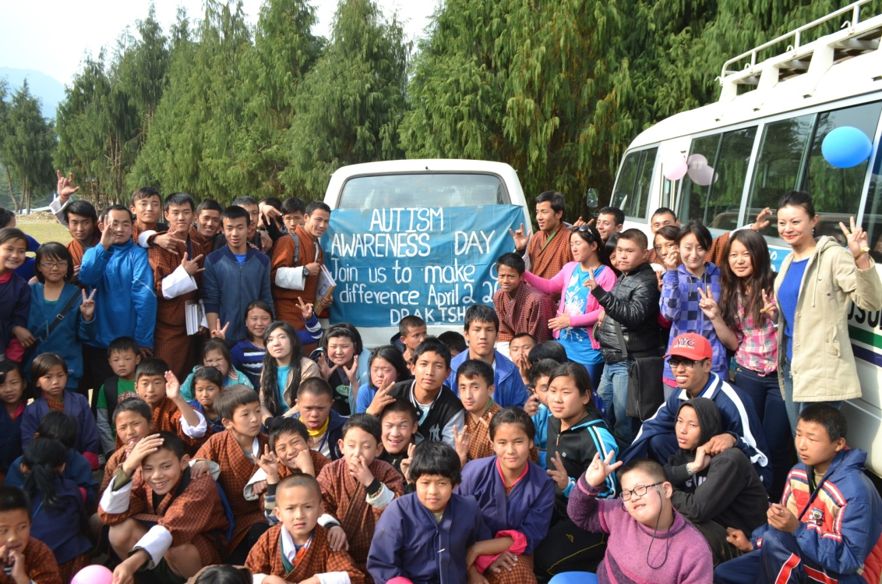

At Paro Drugyel

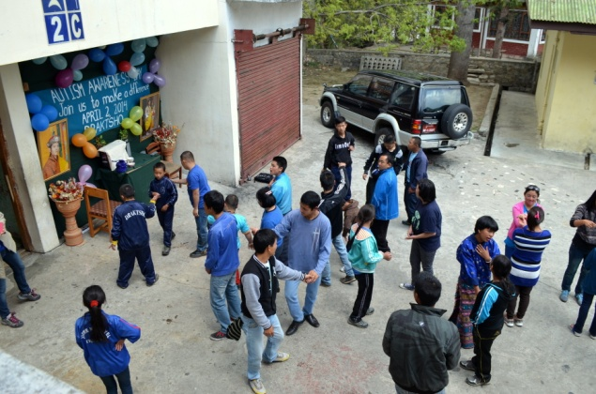 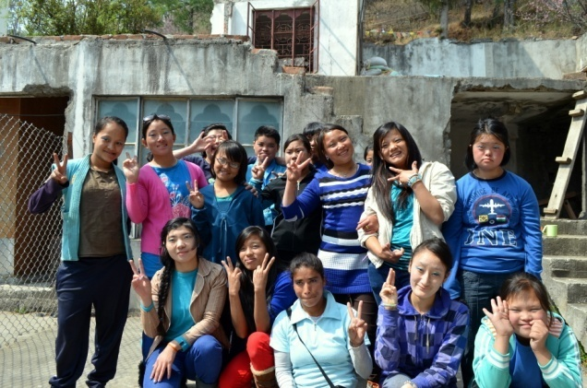

Celebration at Draktsho Thimphu by lighting it up all “Blue”

# **Teachers Day Celebration**

The senior students of Draktsho for the first time took the initiative to organize the “Teachers Day” on 2nd May. The students organized a cultural program where they performed dance numbers for the teachers and also served tea and snacks for everyone. All the initiatives including collection of money for tea and snacks were taken by the senior students. The teachers were overwhelmed with joy and celebrated this day with bliss.

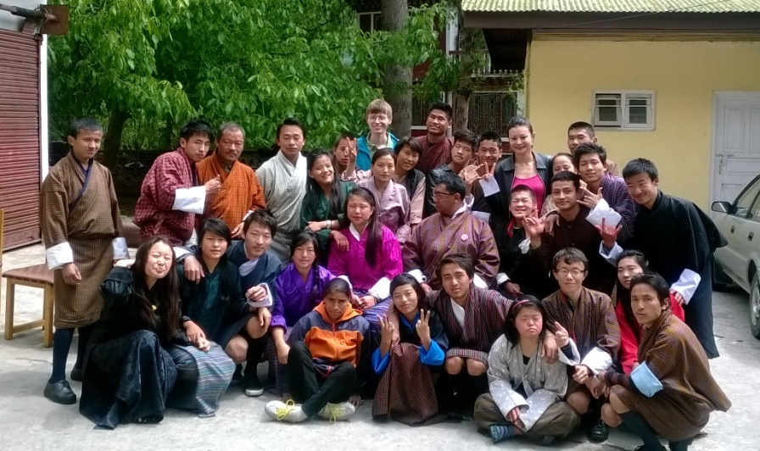 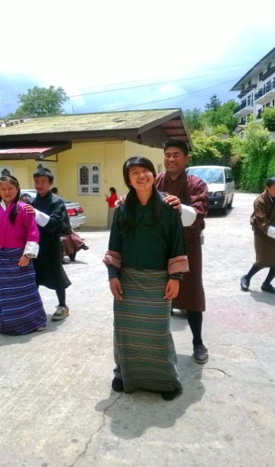

# **Fashion Show**

The Youth Media Centre, a Civil Society Organization in collaboration with Go Youth Go, a youth-initiated group organized a Fashion Show in 12th July,2014. Few students of Draktsho were invited to participate at the “Nazhon Ista” fashion show as models hence the selected underwent grooming and modeling training for two weeks until their final performance. 10 students, 5 boys and 5 girls participated and this was their first time fashion show walking the ramp as models with other able youths. The event was hosted at Taj Tashi Hotel on 12th July.

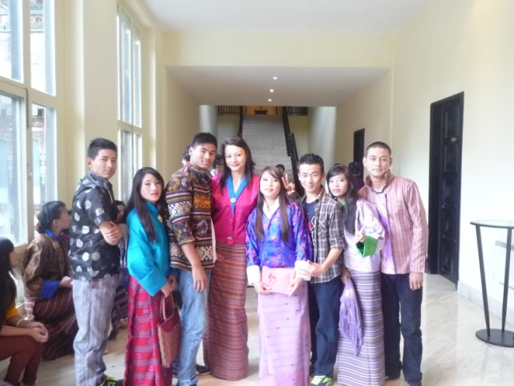 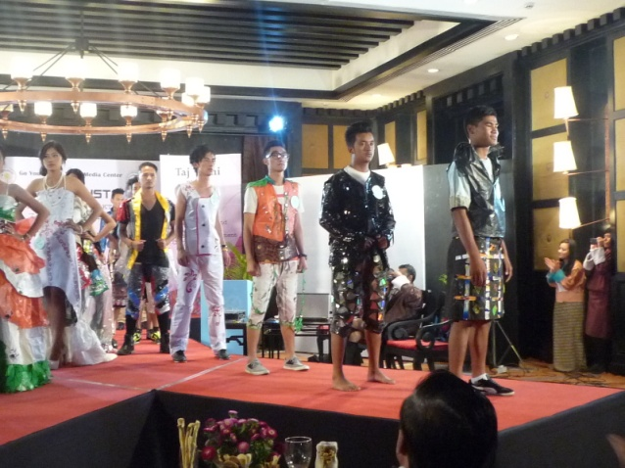

Ms.Deki Zam,Dy.Director with models of Draktsho Phub Tshering a student of Draktsho in front

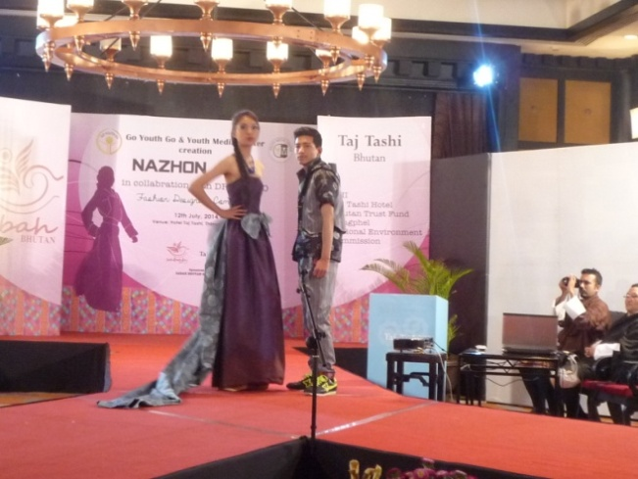 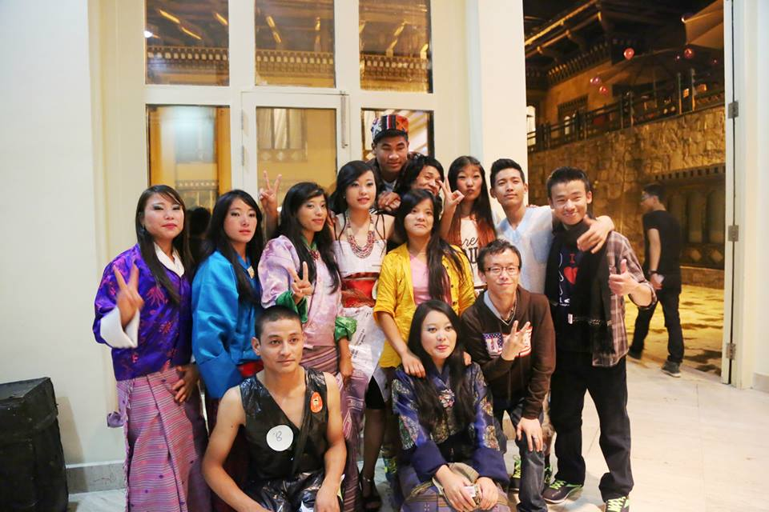

Arjun of Draktsho Draktsho’s proud models

# **Awareness Programme**

Advocacy is one of Draktsho’s main objectives and to fulfill this Draktsho organizes its awareness program annually by showcasing the abilities of the students. This year Draktsho East changed its strategy of raising awareness by going into the communities, meeting the local leaders and other students with and without special needs and interacted with them. Draktsho East organized an “Ability Show” by performing cultural programs like singing, dancing and screening documentary videos. The event took place between May-October on different occasions. The team performed at Sherubtse College, Khaling Lower Secondary School, Muenselling Institute, Uzarong Lower Secondary School and Kanglung Gewog Centre. Such programme helps to change the perceptions of people towards the people living with disabilities thus breaking down the social stigma of “non-acceptance” in the community. The students also initiated a cleaning campaign.

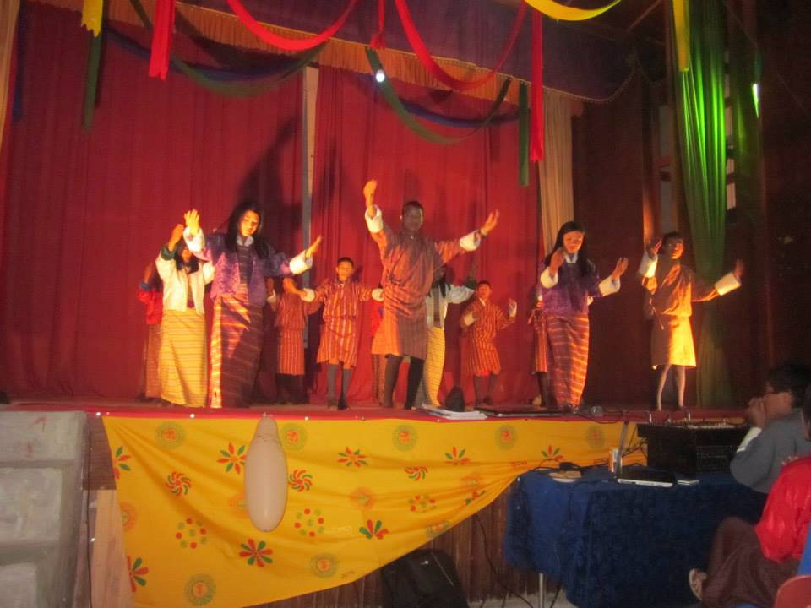 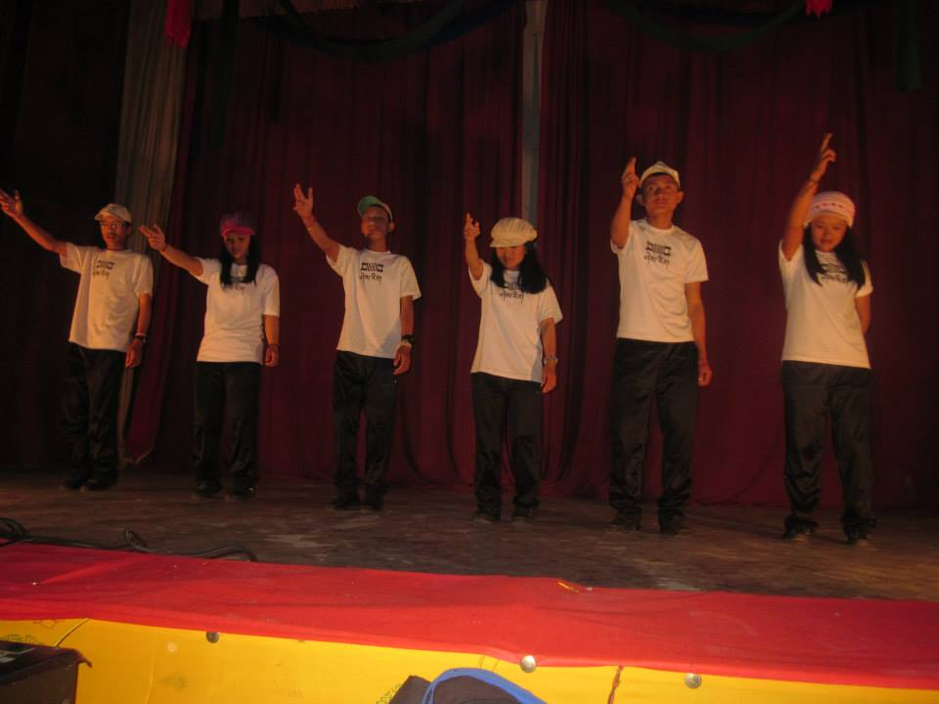

**5.1.** The principal of Drakthso East Mr. Karma Garab Dorji was invited by the Tashigang Dzongkhag Administration as a resource person for a 2 days’ workshop. The workshop mainly focused on the right of person living with the disabilities (CRPD), causes, prevention, early intervention, inclusive education and vocational training. Participants included the principals from various schools and gewog administration who discussed about the issues related to children and youth with disabilities, the challenges this group face with right to education.

# 

# **National Sports Competition**

On 29th August, 2014 Draktsho organized an open national competition for all children and youth with disabilities nationwide. During this competition students from Changangkha Middle Secondary School, Ability Bhutan Society, Deaf Education Unit and Draktsho participated in Olympic type of events. This event was held to select 4 athletes 2 male and 2 females for the upcoming Special Olympics Games in Los Angeles in 2015. There were about 150 special athletes who participated at this event who showcased their abilities by performing equally at their own capacity.

The spectators included eminent individuals from Civil Society Organizations, representatives from United Nations house, government officials, families, friends, teachers, volunteers and other well wishers. The special athletes not only had the opportunity to compete at their own level but demonstrate courage, share views, socialize, meet different families, promote social inclusion and celebrate victory; the feeling of contentment and happiness. The event was graced by the Hon’ble Minister of Ministry of Education. This event was supported by funding from the Christmas Record Grant.

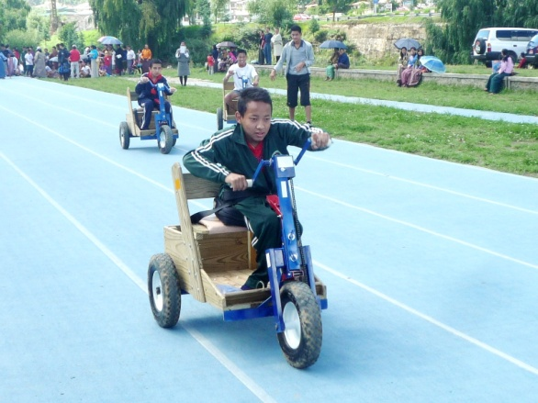 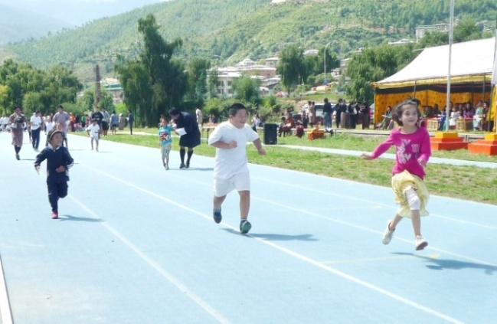

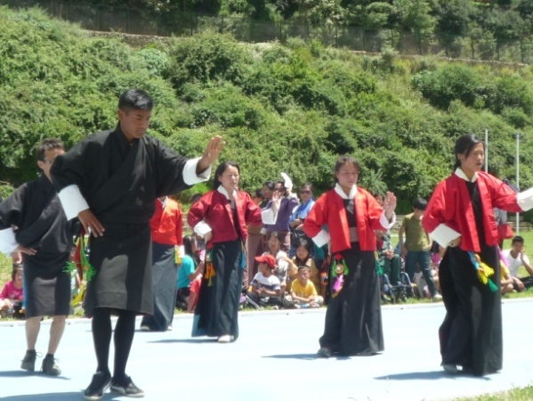 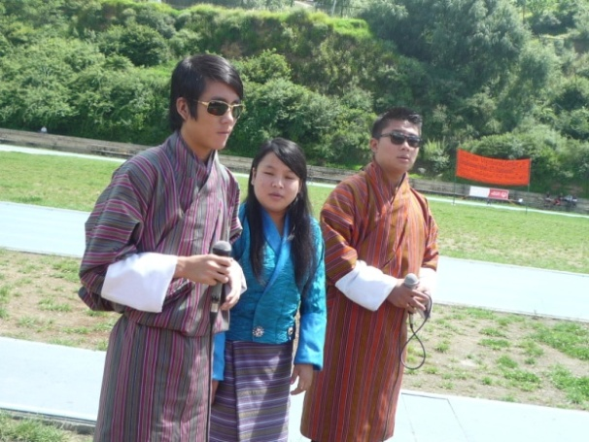

## **Cultural programs performed by persons with disabilities**

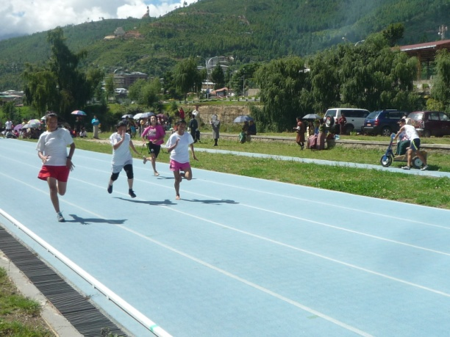 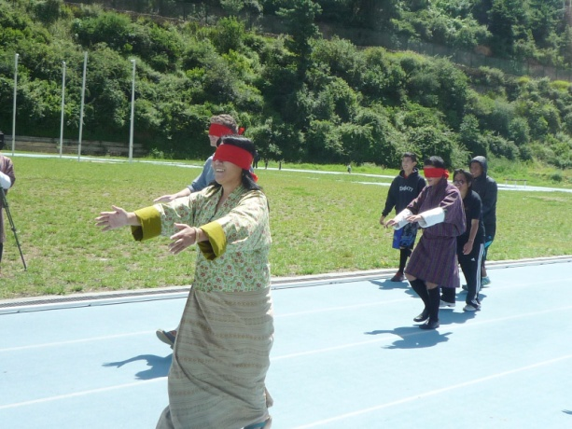

## **Guest participating in the blindfold race**

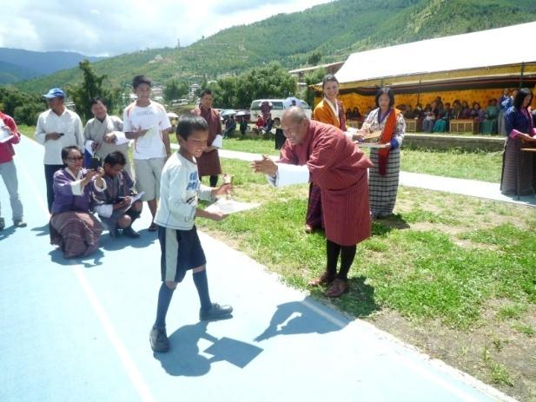 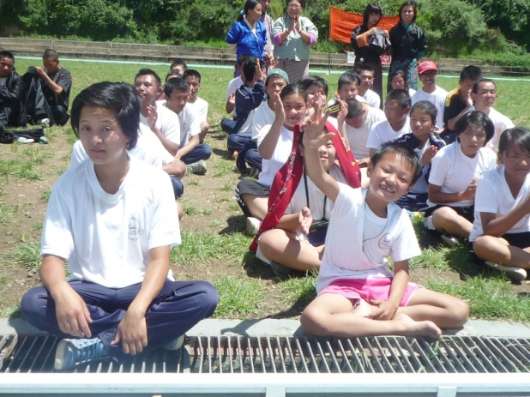

## **Hon’ble Minister Mingbu Dukpa awarding the prizes**

# **Disability Registration Program**

Data collectionof persons with disabilities nationwide has always been one of Draktsho’s long terms and thus in 2014 Draktsho in collaboration with Disabled People’s Association of Bhutan, Ability Bhutan Society, Tarayana Foundation and Bussi-En Group initiated the disability registration program from September 2014-January 2015. The stakeholders decided to start with just 6 districts out of which Draktsho took the initiative to cover Tashigang district. The objective of this disability registry program was to get a correct statistics of persons living with disabilities in various gewogs and villages so as to be able to provide aids such as assistive devices and other type of services available for them.

A team from Draktsho east headed by none other than the principal himself visited the each chewog (sub-block) through proper information from Gups, Tshokpas and health workers in community. The registration was completed within the 5 months. The total number of people residing in Tashigang district was 48,783 out of which 600 people were found living with disability. The types of disability the team across were Down syndrome, Cerebral Palsy, Visual Impairment, Hearing and speech impairment and few leprosy patients too. The most challenging part of this program was transportation, with lack of transportation services such as roads the team had to halt nights on the way just to travel to a village. This program was a very good learning experience for not only Draktsho but all other stakeholders as they had the opportunity to visit every household, talk to the families personally and observe the present situation of people living with disabilities. At the end of program we look forward to a very comprehensive report that will not only include the statistics but all the needs and issues people living with disabilities are facing so as to be able to work on how the relevant stakeholders can help to ease their needs to improve the living standards of this marginalized group.

# **Athlete Leadership Program**

Ms. Kinley Sonam Zangmo an 18-year-old student of Draktsho was selected by Special Olympics Bhutan to undergo 3 days leadership training from 10th-13th November in Singapore. The program known as the Athlete Leadership Program (ALP) was organized by Special Olympics Singapore where Special Olympics Bhutan was also invited to participate to empower youth with intellectual disabilities to become leaders and raise awareness about people living with intellectual disabilities. Ms. Kinley underwent the APL’s training for 3 days where she was joined by special athletes from other countries like Philippines, Brunei, American Samoa, Malaysia, Thailand and Singapore. There were 25 special athletes who underwent the athlete leadership program speech and good governance training.

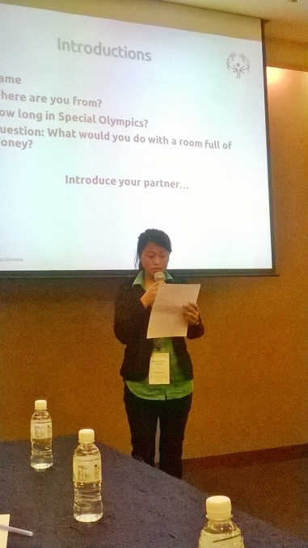 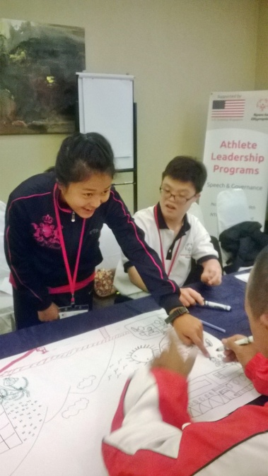 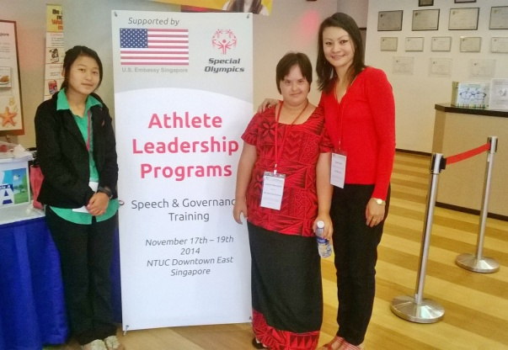

# **Leadership Academy Training**

Ms. Deki Zam, the Deputy Director of Draktsho attended the Leadership Academy Training in Delhi from 2nd-5th December, 2014. This leadership training was organized by Special Olympics Bharat which focused on three important aspects of an emerging leader’s work within Special Olympics: **leadership, governance and planning & execution**. There were about 50 participants from different districts if India and just three international programs were invited out of which Special Olympics Bhutan was one. Ms. Deki Zam is also the Sports Director as well as a coach.

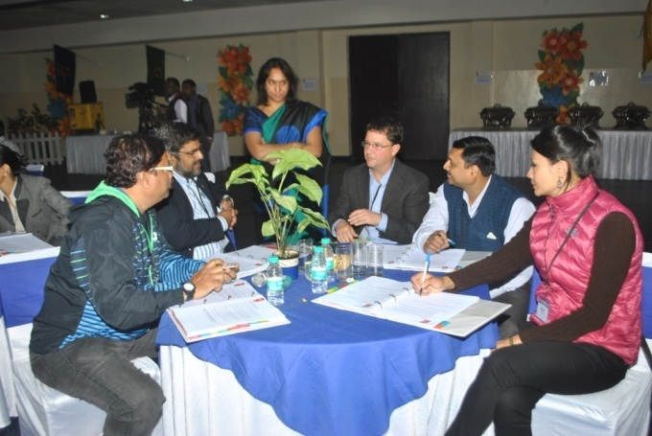 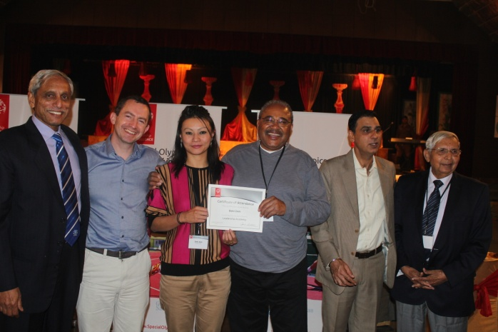

# **Needs Assessment of Draktsho**

In November a needs assessment of Draktsho for the first time was conducted by hiring a professional consultant Dr. Jayanthi Narayan from Hyderabad, India. Dr. Jayanthi visited Draktsho East centre where she met the parents, teachers and also the student through focused group discussions. Dr. Jayanthi was fully engaged during the needs assessment and the following were some of the activities she conducted:

1. Dr. Jayanthi Visited Draktsho East, Changkha Middle Secondary School where she had a separate focused group discussion with special educators and the parents. During the meet she discussed about the services available in India for persons with disabilities, importance of forming a “Parent Support Group”, challenges faced by parents while brining up a child with disabilities and how to deal with these issues.

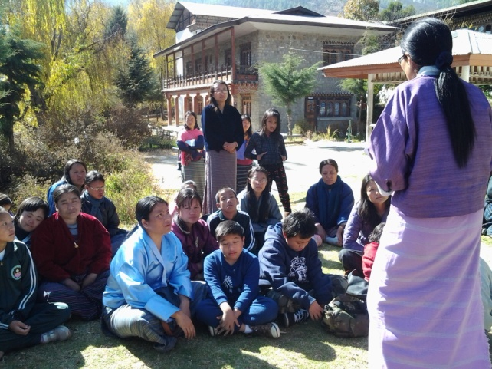 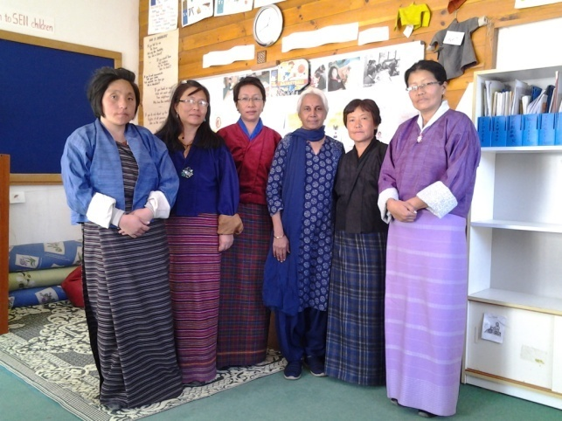

**Parents group discussion Dr. Jayanthi with the teachers**

1. Visited the Special Education Needs (SEN) division, Ministry of Education. Dr.Jayanthi met the Chief and two other officers working in the special education division.
2. Conducted a one day workshop on Special Education for the staffs of Draktsho Thimphu centre.

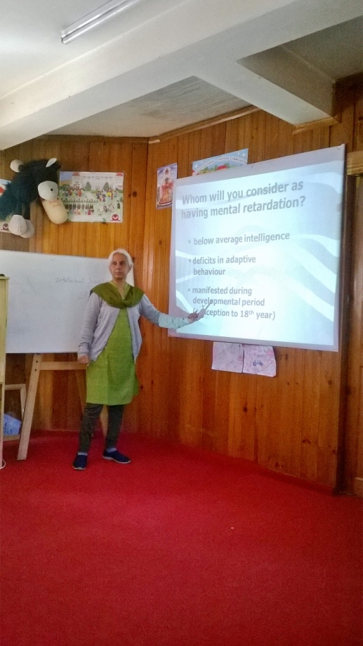 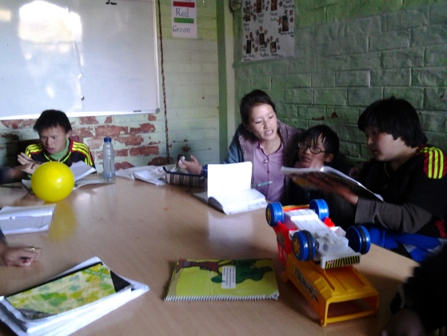

1. Visited Draktsho East Centre and conducted a situational analysis through focused group discussions with parents, teachers and students. Dr. Jayanthi spent few nights at the centre within the campus to get a clear picture of the entire management system for the study.

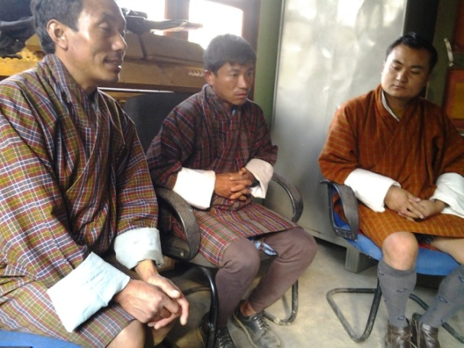 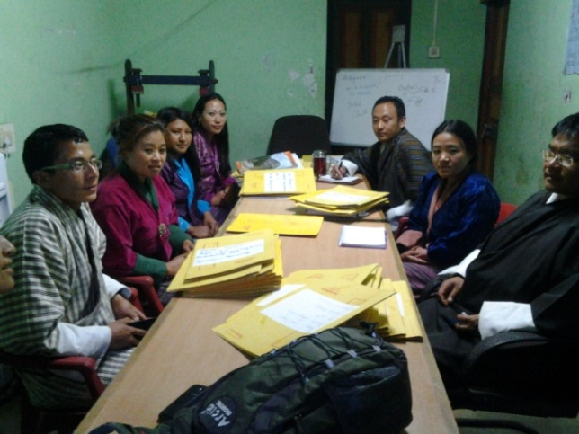

**Meeting the parents and teachers**

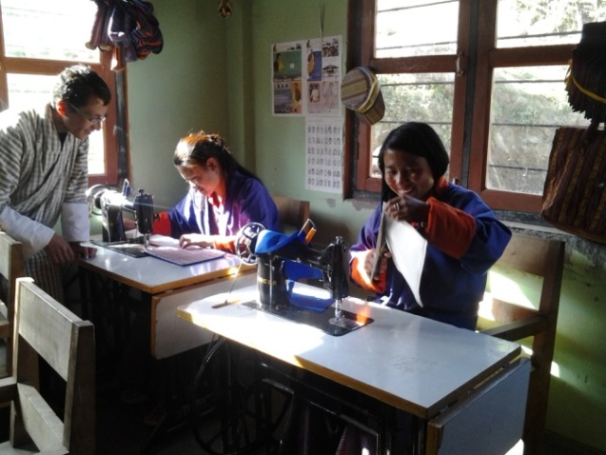 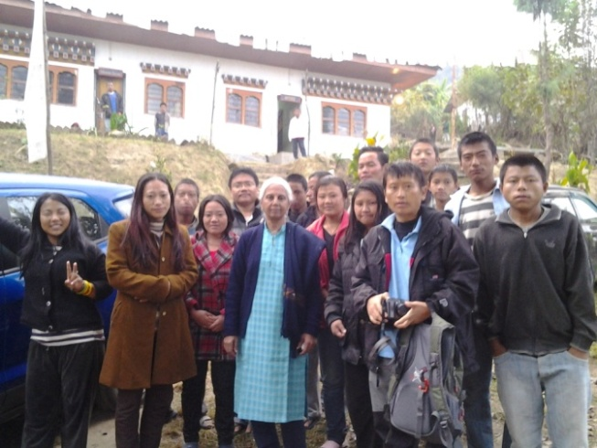

1. Dr. Jayanthi also visited Big Bakery. Big Bakery is the first sheltered employment that was initiated by the founder of Draktsho to provide employment for persons with intellectual disabilities who are not able to find a job in the open labour market. There are 8 persons with disabilities who are currently employed at the bakery. Big Bakery was established in 2010 with support from JICA Bhutan.

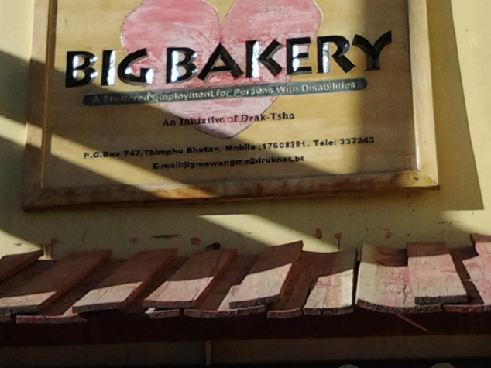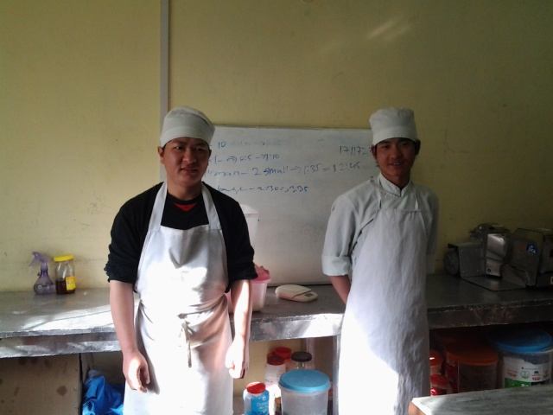

This project of hiring a consultant to conduct a needs assessment of Draktsho was funded by UNICEF Bhutan.

# **Celebration of International Day of Persons with Disabilities**

On 3rd December Draktsho in collaboration with other stakeholders such as the Ability Bhutan Society, Disabled People’s Association of Bhutan, Tarayana Foundation, Bussi-En Company, Bhutan Foundation and Youth Media Centre celebrated the International Day of Persons with Disabilities. On this day a group of students and teachers from the above relevant organizations were invited by Her Majesty The Gyaltsuen to launch a documentary film, this project was initiated by Her Majesty the Gyaltsuen to raise awareness about disability.

The Disabled People’s Association of Bhutan also launched their first music album at the Jehru Wangchuk Cultural House. The album was composed by people living with visual impairment.

The day also commemorated at the centenary park where all families, relatives, members of civil society organizations, volunteers and special children and youth came together to interact and share happiness. Many engaged themselves in cultural programs where as other painted their faces with tattoos and had a grand feast where everyone ate and celebrated by sharing love, care and showcasing.

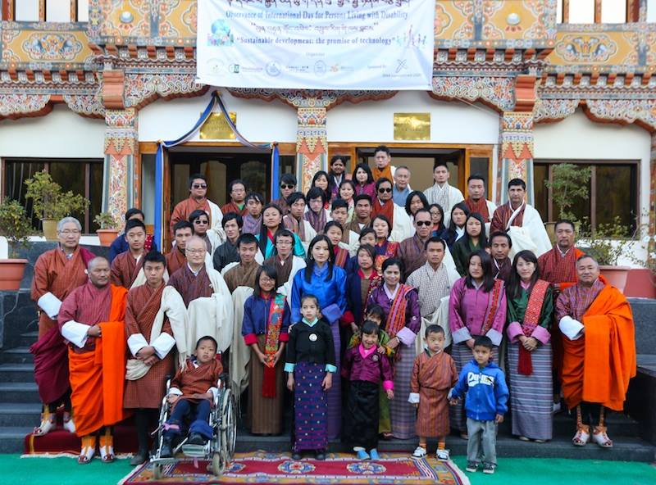

At the launch with Her Majesty The Gyaltsuen

